# AnaplanConnect Interface

This document will outline the features of the PowerShell scripts that are used as wrappers to the standard AnaplanConnect scripts. These PowerShell scripts will enable the following features:

* A file watcher that waits for the arrival of files to start importing into Anaplan that can run through Enterprise Schedulers
* Copy/move, import and backup the source files as required after the Success or Failure of the import
* Connect to SQL data sources by defining the configuration parameters easily
* Provide email notifications of the outcome of the processes
* Optionally can be used to trigger Actions on Anaplan that do not have file operations, but as required through schedulers

## Contents of the ZIP file

The contents of the ZIP file are:

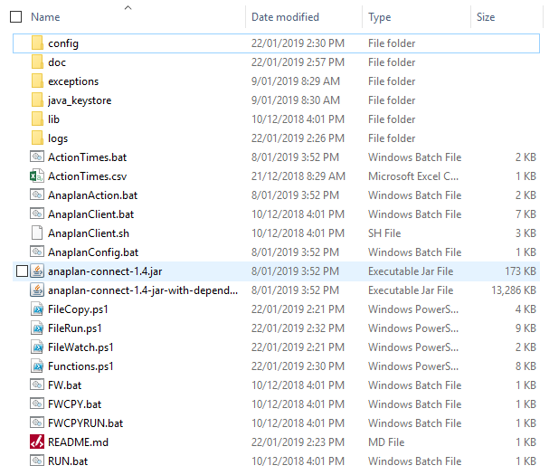

|  |  |
| --- | --- |
| Object | Comment |
| *config* | All configuration files, this folder holds all the files that needs editing as needed by the usage |
| *doc* | Documentations |
| *exceptions* | Folder to hold the errors/messages generated from AnaplanConnect |
| *java_keystore* | Folder to hold the Java KeyStore file for CA Certificate authentication  See: <https://s3.amazonaws.com/anaplanenablement/Community/Anapedia/Anaplan_Connect.pdf> |
| *lib* | Folder that holds the required Java libraries to run AnaplanConnect |
| *logs* | Folder to hold the logging information of the PowerShell scripts |
| *AnaplanClient.bat*  *anaplan-connect.jar* | AnaplanConnect script and Java package |
| *AnaplanConfig.bat* | The connection details for Anaplan (i.e. Basic Authentication or CA Cert details) |
| *AnaplanAction.bat* | Main script that runs the various types of Anaplan Actions |
| *FileWatch.ps1*  *FileCopy.ps1*  *FileRun.ps1*  *Functions.ps1* | Main PowerShell scripts for all operations |
| *FW.bat*  *FWCPY.bat*  *FWCPYRUN.bat*  *RUN.bat* | Windows batch scripts that can be used to call the main PowerShell scripts through Enterprise Schedulers |
| *config\FileInterfaces.ini* | Config file for all file-based operations |
| *config\SQLInterfaces.ini* | Config file for all SQL operations |
| *config\EmailNotifications.ini* | Config file for email notification settings |
| *config\EmailPassword.txt* | Config file to hold the encrypted password for SMTP authentication |

## Step 1 – AnaplanConnect Authentication

The following file should be updated as required to denote the connection type to Anaplan. The connection can be either one of the two possible types:

1. Basic Authentication: Anaplan Username & Password, where the password is maintained by Anaplan and the Anaplan Username is set to be an Exception user for SSO workspaces. The password will need to be reset every 90days.
2. CA Certificate Authentication: A client certificate procured using a Certification Authority that is attached to the Anaplan Username (see: <https://help.anaplan.com/anapedia/Content/Administration_and_Security/Tenant_Administration/Security/Certificates.htm>)

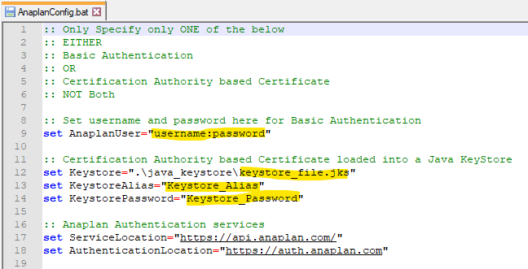

## Step 2 – Email configuration

The following steps need to be complete for email notifications.

1. Update the ***EmailNotifications.ini*** file with the SMTP parameters

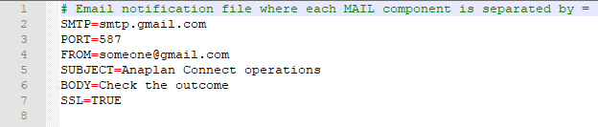

1. As required create the encrypted password file ***EmailPassword.txt*** for the SMTP authentication

To use the default encryption of PowerShell the following command can be issued in the PowerShell prompt and redirect the output to a file as:

"smtpPassword" | ConvertTo-SecureString -AsPlainText -Force | ConvertFrom-SecureString | Out-File ".\EmailPassword.txt"

## Step 3 – File import configuration

This is the main configuration file for all the file import operations. The ***FileInterfaces.ini*** file will have the following information:

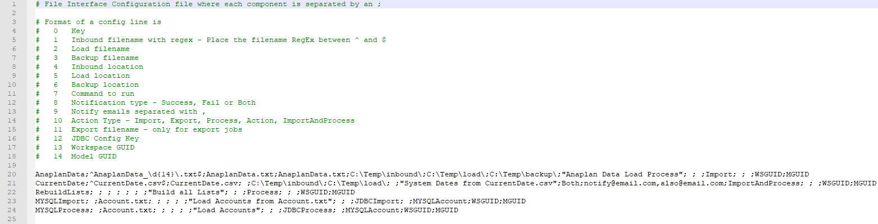

|  |  |
| --- | --- |
| Config Entry | Comments |
| *Key* | **Mandatory** – The main parameter passed to the scripts that picks all the details of the operations |
| *Inbound filename* | **Optional** – The inbound filename as a Regular Expression, so that it can recognise any timestamps |
| *Load filename* | **Optional** – The filename the Anaplan Action is tied to |
| *Backup filename* | **Optional** – The filename the file should be backed-up as |
| *Inbound location* | **Optional** – The folder the file arrives to from a source system |
| *Load location* | **Optional** – The folder the file moves from the inbound location |
| *Backup location* | **Optional** – The folder where the backups lie, which is by date stamped subfolders |
| *Command to run* | **Mandatory** – The Anaplan Action |
| *Notify* | **Optional** – One of Success, Fail or Both |
| *Notify email addresses* | **Optional** – The email addresses comma (,) separated |
| *Action Type* | **Mandatory** – One of Import, Export, Process, Action, ImportAndProcess, JDBCImport or JDBCProcess |
| *Export filename* | **Optional** – Only for Export Action Type |
| *JDBC Config Key* | **Optional** – Only for JDBCImport and JDBCProcess Action Type, if a JDBC Config Key was defined, then the details should be presented in SQLInterfaces.ini |
| *Workspace GUID* | **Mandatory** – Workspace ID |
| *Model GUID* | **Mandatory** – Model ID |

**Note**: The sample file includes example on how the entries should be written.

## Step 4 – SQL import configuration

This is the main configuration file for all the SQL import operations. The ***SQLInterfaces.ini*** file will have the following information:

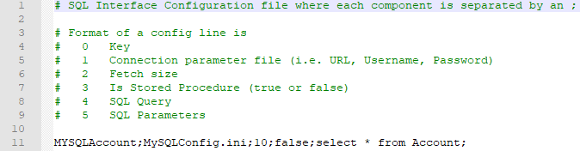

## Step 5 – Calling the scripts

The scripts can be called manually or via an Enterprise Scheduler. The ***Key*** should be passed as the argument. The following scenarios can be provided as examples of these operations.

1. Wait for an arrival of a file, then import it to Anaplan

FWCPYRUN “Key”

1. Run an Anaplan action per schedule

RUN “Key”

## Email notifications

If an email notification is enabled per config entry, a sample with an attachment of any exceptions generated will look like:

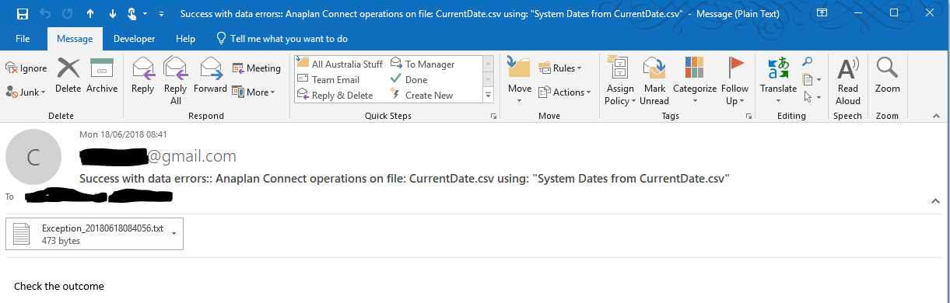

**Note**: The email will contain 1 of 3 statues

1. Success – No issues
2. Success with data errors – Import was successful, but some data items had issues. There will be an attachment with the details of the exceptions generated from Anaplan
3. Fail – The import failed, details will be attached in the email

## Script Logging

All steps of the interface processes will be logged in the ***logs*** folder for each operation (i.e. ***FileWatch***, ***FileCopy*** and ***FileRun***) separately. The generated exceptions will be in the ***exceptions*** folder.

**Note**: There is no process to clean-up the older log files, which should be done on a case-by-case basis.

## Anaplan Logging

In addition to the default History logs in Anaplan, the following steps can be used to capture the actions run through the above scripts.

1. Create a numbered list as:

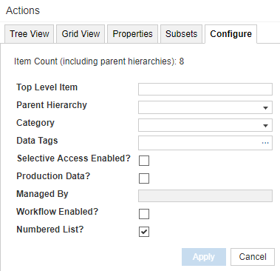

1. Create a module as with the above List and one Text LineItem as:

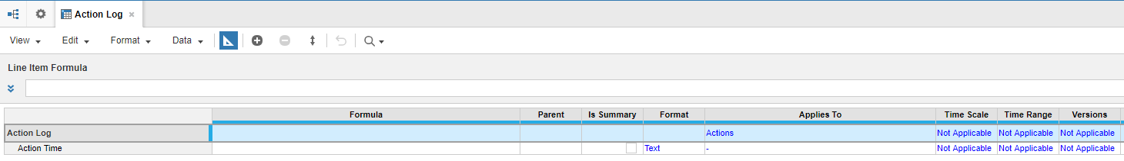

1. Create a Process name “**Update Action Time**”, and include the following Import Actions
   1. Insert new items to the list from the file ActionTimes.csv

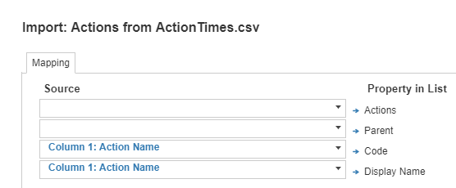

* 1. Load data into the module

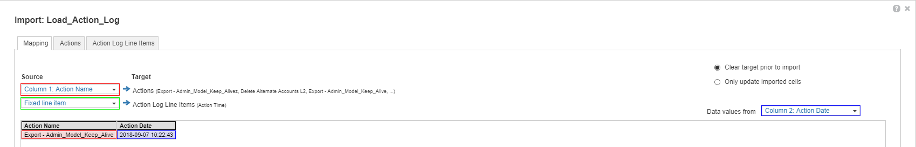

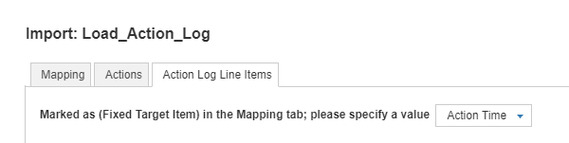

**Note**: A sample file is provided in the ZIP file as:

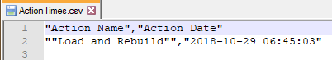

The data captured by the Anaplan Connect actions will be loaded in the module because the Process “**Update Action Time**” is called for every job. This data can be later presented in a dashboard.

